@ Voice of Nations, 4 Anson St, L3 5NY
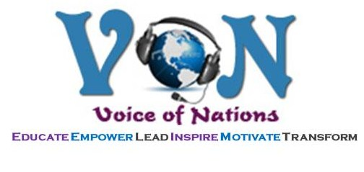

Can Fitness Really Feel This Good?

A treat for your body, mind, emotions & spirit, Nia is performed to diverse & inspiring music blending nine different movements from martial arts, dance arts & healing arts, with the focus on moving your own body’s way and finding pleasure, comfort & ease in your movements.
Come experience the Music, Movement & Magic!
We say Nia is like chocolate – you just have to taste it!
Friday’s
12.30-1.30p.m.
£4.00 Drop-In/£3.50 block/concessions

You can expect to:
♥ Improve Your Flexibility, Agility, Mobility, Strength & Stability
♥ Balance Weight & Tone Up ♥ Increase Your Energy Levels
♥ Create Balance in Your Body, Mind, Emotions & Spirit
♥ Connect With Self & Others ♥ Have Fun Doing It!

